PROJECT DOCUMENTATION

PROJECT TITLE :  **SMART ROBOT WITH WEB PAGE**

TEAM MEMBERS :

T.MADHURI

B.RAJITHA

S.AISHWARYA

V.S.N PRAMILA

BASIC AIM :

To make a robot embedded with various sensors to detect various dangerous gases in the industries and factories on the they production purpose, and implement those in many things, like in the environmental liesence, giving presentations and many more. Motivation: We were having a look at previous year projects done under the electronics club, we saw many technical robots made by the suprious. So we thought of a smart robot that can work for all the latest technical communications and whether readings, is full featured, and looks more realistic using that. Inspired by things like Microsoft© Kinect™, Sony© Play Station™ motion controller, and many more such robotics available in the market, we came up with this idea.

so , very interesting thing in making of technical robots which are manufactured by the technist and developers, every one had a dream to do this types of project which is used for many people has to complete they work more faster in simple manner. We are using this in many electronic gadgets which makes our time specify and save from complexive nature.

THEORY :

*sensors*

TEMPERATURE SENSOR

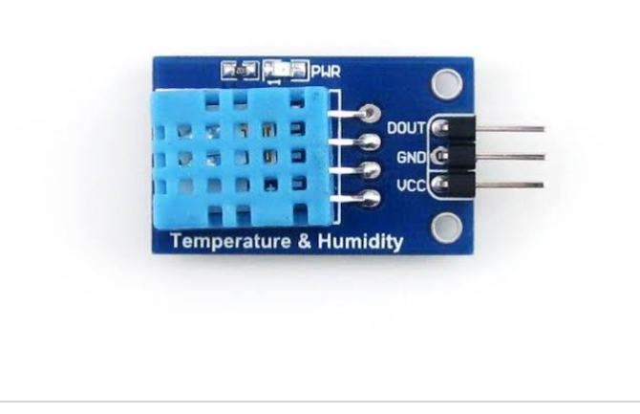This *[**DHT11 Temperature and Humidity Sensor**](https://www.dfrobot.com/product-174.html)* features a calibrated digital signal output with the temperature and humidity sensor complex. Its technology ensures the high reliability and excellent long-term stability. A high-performance 8-bit microcontroller is connected. This sensor includes a resistive element and a sense of wet NTC temperature measuring devices. It has excellent quality, fast response, anti-interference ability and high cost performance advantages.

Each DHT11 sensors features extremely accurate calibration of humidity calibration chamber. The calibration coefficients stored in the OTP program memory, internal sensors detect signals in the process, we should call these calibration coefficients. The single-wire serial interface system is integrated to become quick and easy. Small size, low power, signal transmission distance up to 20 meters, making it a variety of applications and even the most demanding applications. The product is 4-pin single row pin package. Convenient connection, special packages can be provided according to users need.

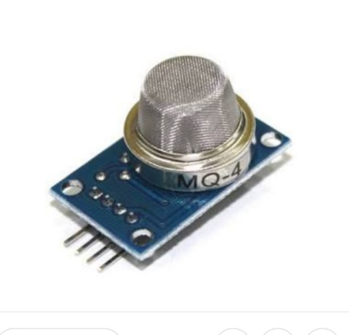*GAS SENSOR :*

A **gas detector** is a device that detects the presence of [gases](https://en.wikipedia.org/wiki/Gas) in an area, often as part of a [safety system](https://en.wikipedia.org/w/index.php?title=Safety_system&action=edit&redlink=1). This type of equipment is used to detect a [gas leak](https://en.wikipedia.org/wiki/Gas_leak) or other emissions and can interface with a [control system](https://en.wikipedia.org/wiki/Control_system) so a process can be automatically shut down. A gas detector can sound an alarm to operators in the area where the leak is occurring, giving them the opportunity to leave. This type of device is important because there are many gases that can be harmful to organic life, such as humans or animals.

Gas detectors can be used to detect [combustible](https://en.wikipedia.org/wiki/Combustible), [flammable](https://en.wikipedia.org/wiki/Flammable) and [toxic](https://en.wikipedia.org/wiki/Toxic) gases, and [oxygen](https://en.wikipedia.org/wiki/Oxygen) depletion. This type of device is used widely in industry and can be found in locations, such as on oil rigs, to monitor manufacture processes and emerging technologies such as [photovoltaic](https://en.wikipedia.org/wiki/Photovoltaic). They may be used in [firefighting](https://en.wikipedia.org/wiki/Firefighting).

*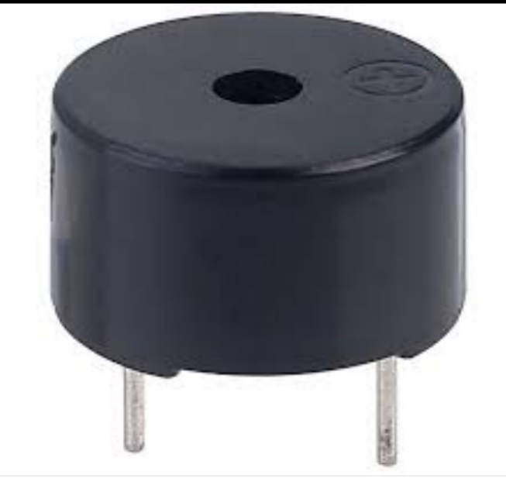BUZZER*

The electric buzzer was invented in 1831 by [Joseph Henry](https://en.wikipedia.org/wiki/Joseph_Henry). They were mainly used in early [doorbells](https://en.wikipedia.org/wiki/Doorbell) until they were phased out in the early 1930s in favor of musical chimes, which had a softer tone.[[2]](https://en.wikipedia.org/wiki/Buzzer#cite_note-2)

[Piezoelectric](https://en.wikipedia.org/wiki/Piezoelectricity) buzzers, or piezo buzzers, as they are sometimes called, were invented by Japanese manufacturers and fitted into a wide array of products during the 1970s to 1980s. This advancement mainly came about because of cooperative efforts by Japanese manufacturing companies. In 1951, they established the Barium Titanate Application Research Committee, which allowed the companies to be "competitively cooperative" and bring about several piezoelectric innovations and inventions.[[3]](https://en.wikipedia.org/wiki/Buzzer#cite_note-3)

*DC MOTOR :*

A **DC motor** is any of a class of rotary electrical machines that converts direct current electrical energy into mechanical energy. The most common types rely on the forces produced by magnetic fields. Nearly all types of DC motors have some internal mechanism, either electromechanical or electronic, to periodically change the direction of current flow in part of the motor.

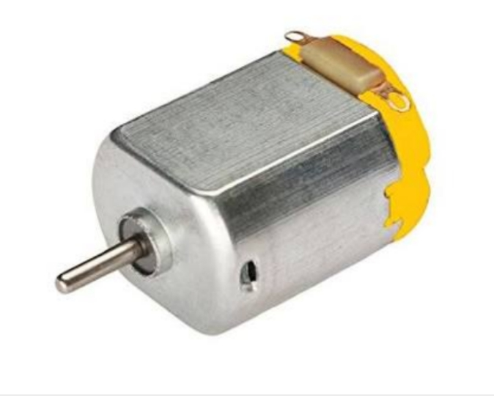DC motors were the first form of motor widely used, as they could be powered from existing direct-current lighting power distribution systems. A DC motor's speed can be controlled over a wide range, using either a variable supply voltage or by changing the strength of current in its field windings. Small DC motors are used in tools, toys, and appliances. The [universal motor](https://en.wikipedia.org/wiki/Universal_motor) can operate on direct current but is a lightweight [brushed](https://en.wikipedia.org/wiki/Brush_(electric)) motor used for portable power tools and appliances. Larger DC motors are currently used in propulsion of electric vehicles, elevator and hoists, and in drives for steel rolling mills. The advent of power electronics has made replacement of DC motors with [AC motors](https://en.wikipedia.org/wiki/AC_motors) possible in many applications.

*MICRO CONTROLLER :*

*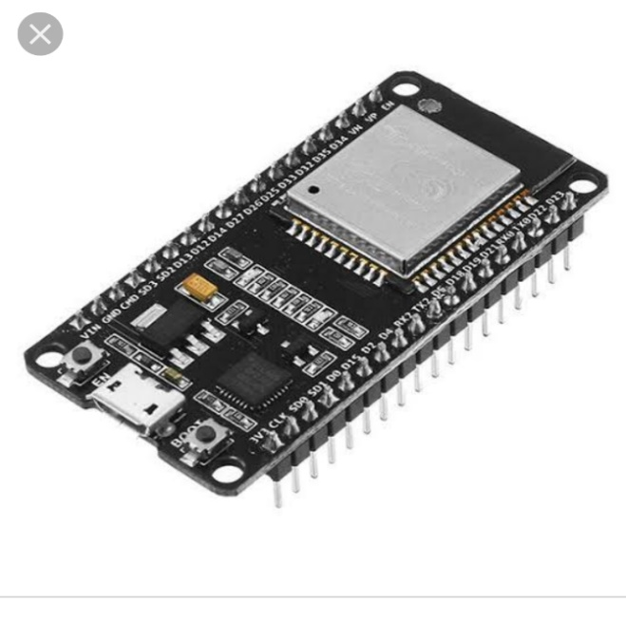ESP32*

A microcontroller is a small computer on a single integrated circuit containing a processor core, memory, and programmable input/output peripherals. The one we used is ESP32. ESP32 is a single-board microcontroller designed to make the process of using electronics in multidisciplinary projects more accessible. The hardware consists of a simple open source hardware board designed around an 8-bit Atmel AVR microcontroller. An ESP32board consists of an Atmel 8-bit AVR microcontroller with complementary components to facilitate programming and incorporation into other circuits. An important aspect of the esp32is the standard way that connectors are exposed, allowing the CPU board to be connected to a variety of interchangeable add-on modules known as shields. The software consists of a standard programming language compiler and a boot loader that executes on the microcontroller.

*COMMUNICATION*

We have used Serial communication (also known as UART) to send data from ESP32 to the computer through USB serial COM ports. UART: A Universal Asynchronous Receiver/Transmitter, abbreviated UART, is a piece of computer hardware that translates data between parallel and serial forms. UARTs are commonly used in conjunction with communication standards such as EIA, RS-232, RS-422 or RS-485. We used UART to transfer our data from ESP32 to the computer through serial COM ports for further processing.

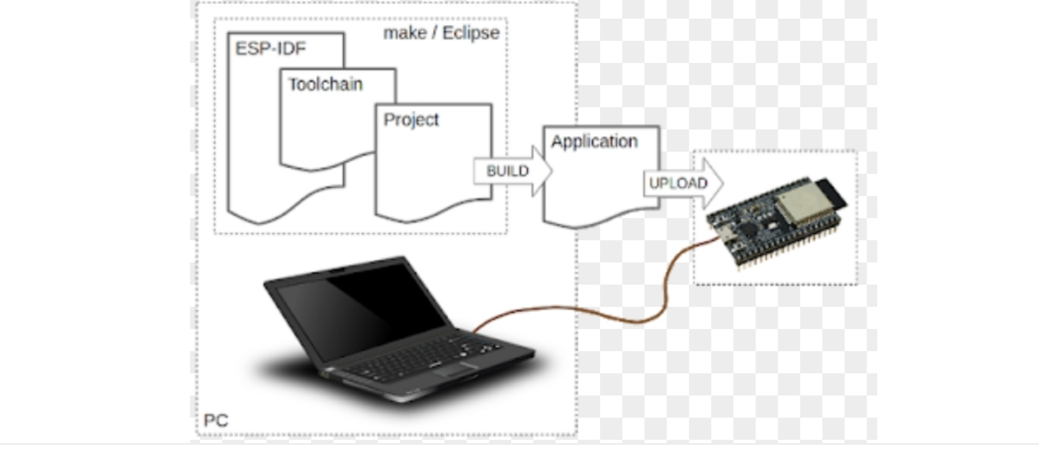

*ARDUINO IDE :*

Arduino IDE is a collection of application programming interfaces (APIs) for handling tasks related to multimedia, especially for any updated board programming , on Microsoft platforms.

*PROGRAMMIG PLATFORMS :*

For programming the ESP32, we have used the default ARDUNIO IDE. The code running on the computer which receives the data from serial port, and decodes it to perform various functions is written in C

*IMPLEMENTATION :*

* All the components are giving readings to the ESP32, where we are converting these readings into character code in order to send the bytes efficiently and quickly to

the computer. Inside a never ending loop, every reading corresponds to a character. So a package is created every time the loop runs, and that is sent to the computer. This package contains the data coming from each and every sensor, and finally this needs to be decoded on the computer to get the readings.

* A code should run on the computer in order to receive the data that is being sent by ESP32 via serial ports. This code is written in C language. The function com->connect() initializes the serial communication between the computer and ESP32. We have written a library in which we have defined this function. The connection is refreshed on starting of the loop so that the values do not get mixed up.
* The character code is decoded according to the algorithm, and now the data is used to control the mouse and the keyboard. The functions to move the mouse and pressing the keys of the keyboard

*FINAL WORKING :*

By operating the dc motors the robots will able to move in the forward,backward,right and left where the code dump in ESP32 board

Through sensors the input is detected and

reading the values from the sensor and printing in the web page which can be abe control from the server .It can be detect the gas which it is assigned to the sensor.

Whenever a dangerous gas is produced it buzz it’s buzzer

*UTILITIES :*

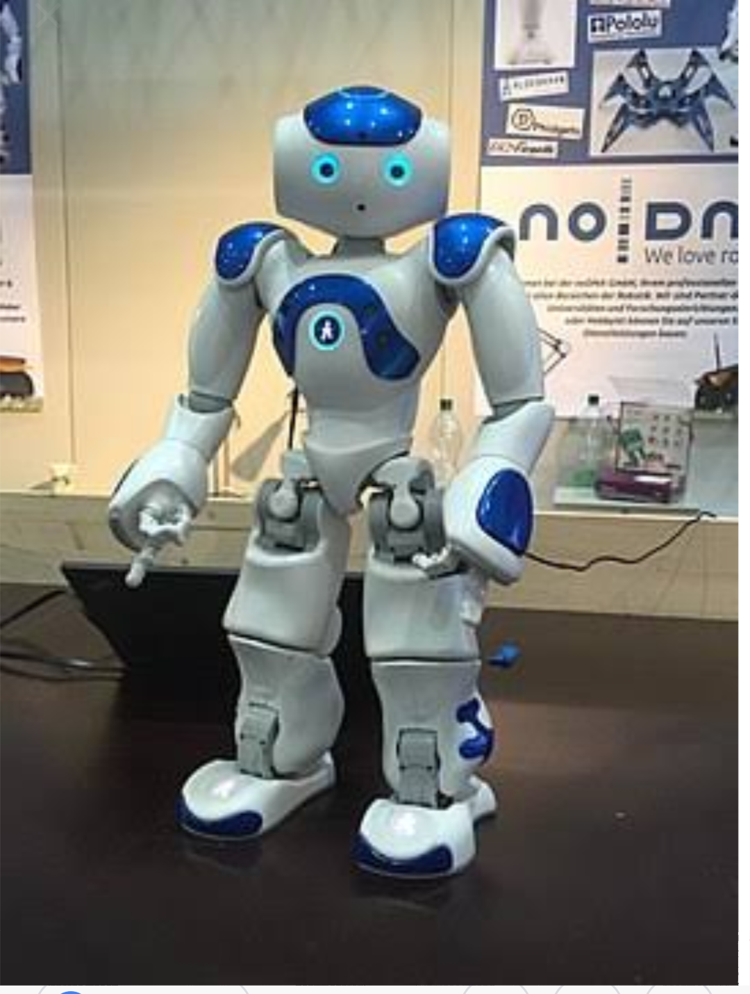

*FURTHUR DEVELOPMENTS:*

It can be used not only the industrial purpose but also in the ARMY & NAVYA no family is not be a ease to death of loved one by making them as the protector no one can save them like them.